*Florida International University*

*School of Computing and Information Sciences*

CIS 4911 - Senior Capstone Project

Software Engineering Focus

Feature Document

User Story #662

**Team Member:**

Andrew Mitchell

**Product Owner(s)**:

Francisco R. Ortega

**Mentor(s)**:

Francisco R. Ortega

...

**Instructor**: Masoud Sadjadi

**User Story -** Add Layer Transparency

* As a User I would like to make each individual layer as transparent as I want to make it easier to see which layers I am working on.

Acceptance Criteria

* Create Buttons for layer transparency
* Each layer is independent of one another

**Use Case**

Use Case

Enable user to drag a slider to change image transparency on specific layers.

Details:

Actor: User

Pre-conditions:

Multitouch must be running.

Mode buttons enabled.

Layer Visualization Menu must be enabled.

Description:

Use case begins when the user opens the layer visualization menu. The user can then drag the green dot next to each layer to change how transparent each layer is.

Post-conditions:

Depending on the dot’s position, the layer will reflect a certain transparency( Only affecting that layer).

Decision Support:

Frequency: Often. Being able to visualize the layers more properly by adding transparency to some of them is a drawing tool used by many people.

Criticality: High. The product owner really likes the idea of Alpha color (transparency) control. Enabling this for individual layers is a great way to do this.

Risk: High. Implementing a ‘sliding’ button may provide some trouble, as well as making sure we are affecting the proper layer when using the button.

Reliability: Highly.

Mean time to Failure –  Never. When the user drags their finger the layer should properly change transparency.

Availability –Available when multitouch device is enabled. The user must also open the ‘layer visualization menu’ which is a ‘mode button’

Performance:

No performance impact.

Supportability:

Acer Multitouch

Modification History:

Owner: Andrew Mitchell

Initiation date: 3/28/2016

Date last modified: 4/3/2016

**Use Case Diagram**

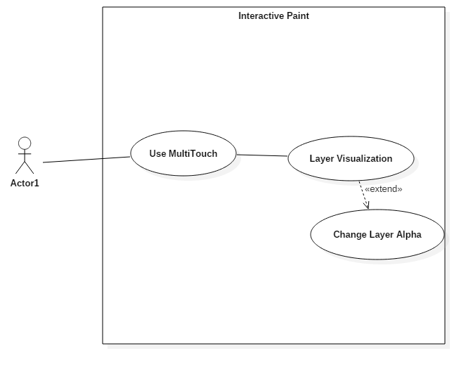

**Sequence Diagram**

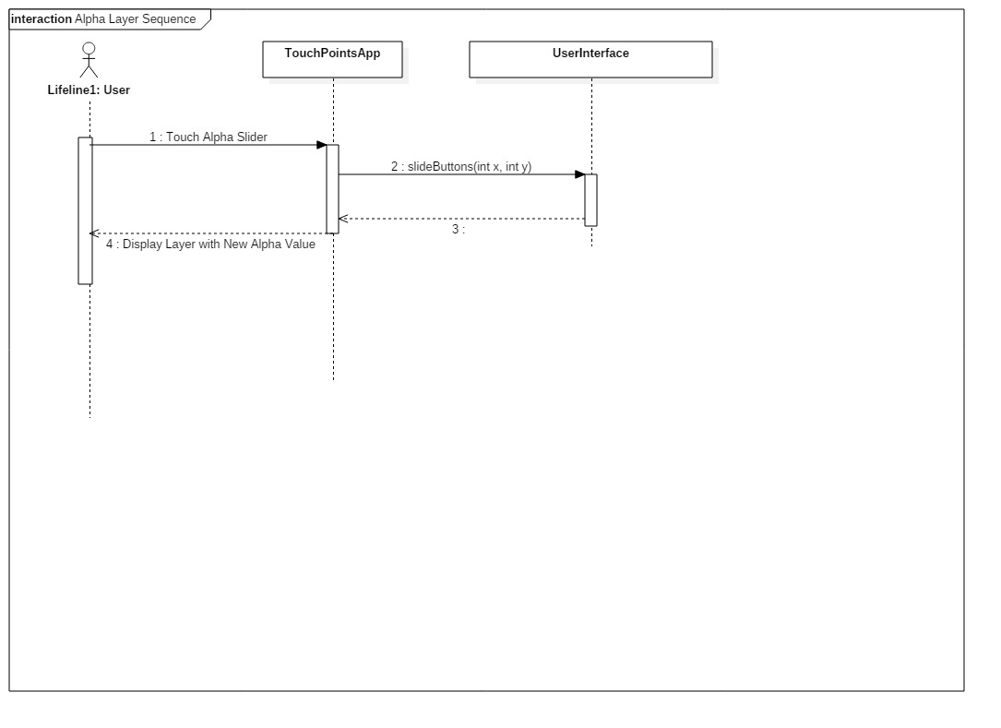

**Class Diagram**

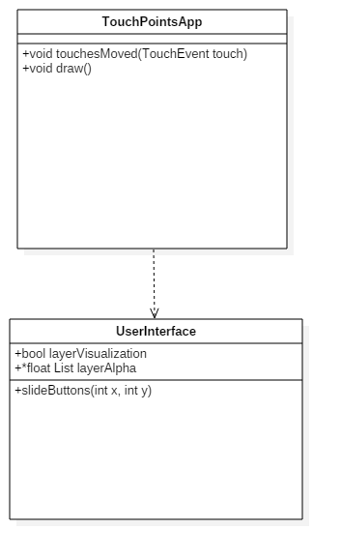

**Unit Test**

Sunny Day :

Test Purpose:

To ensure layers successfully change alpha color when using the slider.

Test Setup

1. Draw a filled circle with any color
2. Open Layer Visualization menu
3. Slide your finger along the slider next to the layer which your circle in drawn

Test Output:

When the finger slides upward, the image becomes more transparent. When the finger slides down the image becomes less transparent (more visible).

Expected Output:

When the finger is placed on the slider it should change the alpha depending on where the touch occurred, higher on the scale means it is more transparent, lower on the scale makes it more visible.

Rainy Day Tests:

Test Purpose:

Ensure altering alpha color with slider only affects that one specific layer.

Test Setup:

1. Draw a filled circle with any color
2. Open Layer Visualization menu
3. Switch layers by touching the bottom or middle layer.
4. Draw a filled circle at a separate location from the first.
5. Slide your finger along the slider next to the layer which either circle in drawn on.

Test Output:

When the user slides their finger along the slider, only one of the two circles are affected.

Expected Output:

Only the circle within the layer you are doing the ‘sliding’ next to should be affected.

**Integration Test**

Layer transparency is currently working with the TouchPointsApp. It is successfully integrated the User Interface and can work using the multitouch device to activate the menus and slider functionality.

It has also been integrated with the Save functionality so the layer transparency works with our save functionality as well.

Drawing with the leap motion as well as the Multitouch devices still works as anticipated when drawing with different alphas on the current layers.

Works with all colors and shapes.

**User Guide**

Open the layer visualization menu. Then, beside the images of your layers, place your finger and move it up and down along the left side blocks. The green dot indicates the current transparency of the layer (Higher, or lighter, is more transparent, lower, or darker, is less transparent).

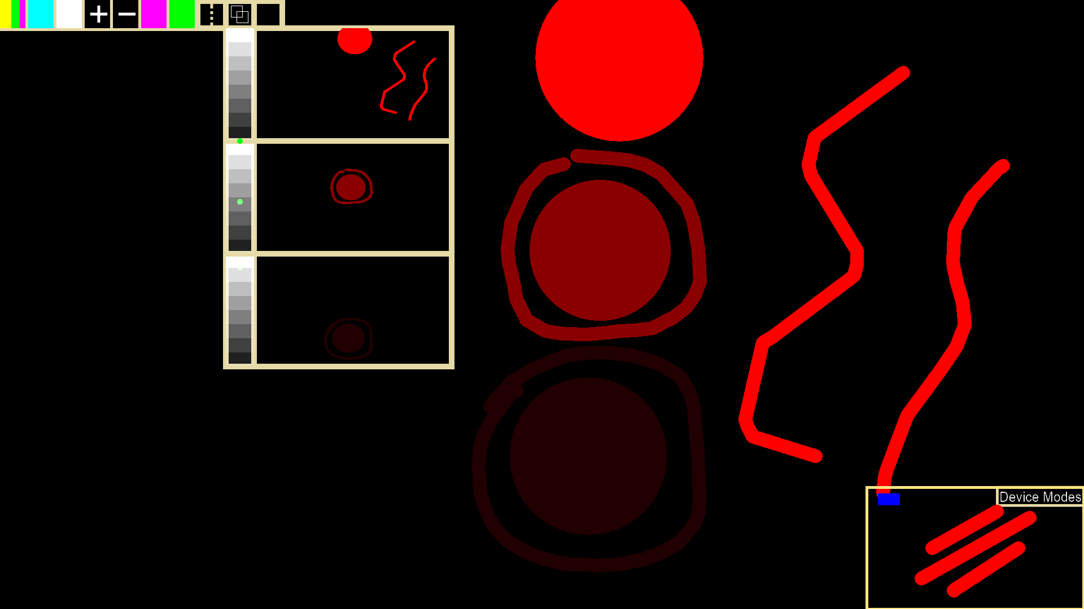

Devices: Multitouch

**Glossary**

Alpha Layers – The alpha value associated with each individual layer.